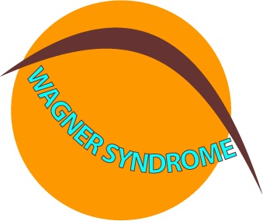
Wagner syndrome & glaucoma
In 1966 a thesis was published in the Netherlands bij L.M.A.A. Jansen about two Dutch families with Wagner disease / syndrome. In this thesis Jansen claimed that 50% of the affected family members had glaucoma. In those days an elevated intraocular pressure was seen as a symptom of glaucoma. However, since nowadays an elevated IOP is considered as a risk factor rather than a symptom, we like to evaluate his findings. That there was a raised IOP in these families is evident, but in fact there was hardly any glaucomatous damage. Therefore, it might be possible that an elevated IOP is a feature of Wagner syndrome, without being a risk factor for glaucoma in these patients. To provide the best treatment, we would like to ask you for your cooperation in this matter by sharing with us some findings in your patients.
Your data
Name .......................................................
Hospital / Office .......................................................
Department .......................................................
Address .......................................................
Phone number .......................................................
Email address .......................................................
Patient data
Name ...........................................................
Date of birth ....................................... m/f ...........
Country ...........................................................
City ...........................................................
Has there been a DNA-test on Wagner’s disease with this patient or his/her relatives? yes / no
What were the results? ..........................................
Department of Ophthalmology
M.A.D. Tilanus, MD PhD
m.tilanus@ohk.umcn.nl
PO Box 9101
6500 HB Nijmegen
tel. 00 31 (0) 24 361 4448
fax 00 31 (0) 24 354 0522
www.wagnersyndrome.eu
VA
Visual acuity
Refraction (sph / cyl / axis)
Lens status phakic / pseudo phakic / aphakic
Refraction prior to lens extraction (sph / cyl / axis)

IOP
measured with Goldmann / Pascal (please indicate)

IOP
IOP (date ± 2 years back): ..... ..... ............... (date)
Is the patient using IOP lowering medication?
If yes since ..... ..... ............... (date)
Has there been any IOP lowering surgery performed?
If yes, when ..... ..... ............... (date)

Retinal detachment surgery
Was there any surgery for RD performed?
If yes, what kind? …………………………………

CCT
We would like to establish also if with these patients the IOP is influenced by the corneal thickness. Could you measure this as well?
CCT
measured with ..................................................

Glaucoma
Do you see glaucomatous damage of the optic disc?
Please see that the following images are taken:
- color picture (disc 15°)
- OCT spectralis (nerve fibre layer)
Could you describe the anterior chamber angle?
(See Spaeth gonioscopic grading system)
Do you see glaucomatous changes in the visual field?

General health, does the patient has
Diabetes no / yes / not known
Hypertension (blood) no / yes / not known

OD
.......
.... .... ....

.... .... ....

....... mmHg
....... mmHg
yes / no

yes / no

yes / no

....... µm

yes / no

......................

yes / no /
not measured

OS
.......
.... .... ....

.... .... ....

....... mmHg
....... mmHg
yes / no

yes / no

yes / no

....... µm

yes / no

......................

yes / no /
not measured

Please send this form to the (email) address in the header. You will be informed about the results of this research, in person, but also on the website. Of course we would appreciate it if you could add information about other Wagner patients in your care. Thank you very much. Sincerely yours, Mauk Tilanus
date ........ ........ 20 .....

